COVER PAGE
PROJECT TITLE: HOSPITAL MANAGEMENT SYSTEM
COURSE -CSE2006
INSTRUCTOR-DHEERESH SONI
SUBMITTED BY-SHIVAM KUMAR SHAH
REG.NUM.-25BAI10991
DATE-18 SEPTEMBER 2026
INSTITUTION-VIT BHOPAL

Hospital Management System

A Comprehensive Analysis of Object-Oriented Architecture, System Design, Data Structures, and Implementation Workﬂows for Clinical Operations.

Prepared for: Software Engineering Department Language Platform: Java SE (Standard Edition) Architecture Type: In-Memory Object-Oriented System Document Version: 2.0 (Final)

TABLE OF CONTENTS

- Executive Summary & Project Overview
- Problem Statement & Domain Requirements
- System Architecture & Design Patterns
- Core Entity Speciﬁcations
- Functional Workﬂow & Sequence Analysis
- Source Code Architecture & Implementation
- Data Structures & Algorithmic Analysis
- Validation, Testing & Error Handling
- Comparative Evaluation & Advantages
1 0. Future Roadmap & Extension Guidelines

1 . EXECUTIVE SUMMARY

Modern healthcare facilities require dependable information systems to streamline administrative processes, maintain compliance, and reduce clinical human error. The Hospital Management System (HMS) is an object-oriented Java SE application engineered to manage core clinical workﬂows: patient record management, physician scheduling, appointment booking, diagnosis logging, and consultation invoicing.
By digitizing manual workﬂows, the system achieves instant record lookup, consistent ID allocation, and real-time generation of billing artifacts. This report presents an exhaustive engineering overview of the system architecture, entity design, data ﬂow, complexity bounds, and extensibility path.

Small to medium-scale healthcare practices often face operational friction caused by fragmented manual record-keeping. Key issues include missing medical histories, delayed patient routing, scheduling conﬂicts, and billing discrepancies.

Operational Challenges
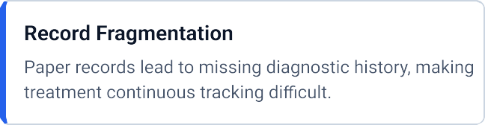
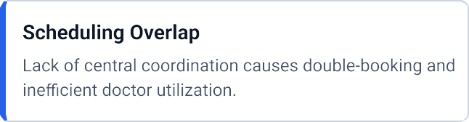
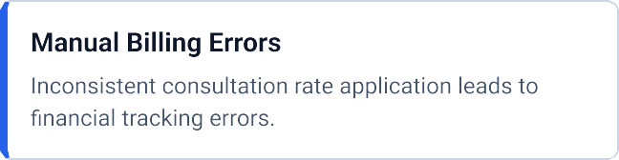
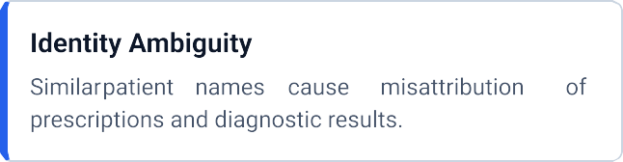

Functional Requirements Matrix

Req ID | Module | Functional Description | Priority
FR-01 | Patient Management | Register new patients with automated incremental identiﬁcation numbers. | High
FR-02 | Doctor Management | Maintain active physician proﬁles, ﬁeld specializations, and fee scales. | High
FR-03 | Appointments | Bind active patients to doctors with date validation and status tracking. | Critical
FR-04 | Medical Records | Append diagnoses and prescriptions directly to patient proﬁles. | Critical
FR-05 | Invoicing | Auto-generate invoices linked to consultation rates upon appointment creation. | Medium

The software uses a layered Object-Oriented Architecture separating entity data classes, workﬂow management logic, and the user interface controller layer.

Structural Class Diagram Overview

Entity Speciﬁcations
    - Patient Class: Manages personal identiﬁcation and encapsulates a list of `MedicalRecord` objects, shielding medical history from global mutation.
    - Doctor Class: Serves as an immutable registry entry representing medical staff parameters.
    - Invoice Class: Captures billing events, storing payment states (`PAID` / `UNPAID`) and ﬁnancial tracking data.

The HMS ensures controlled data ﬂows across administrative tasks. The main system execution sequences follow structured state transitions.

Appointment & Billing Workﬂow Sequence

Step | Actor /  Component | Action Performed | System State Change
1 | Receptionist / User | Submits Patient ID, Doctor ID, and Date. | Input stream validation initiated.
2 | HospitalApp | Invokes stream lookup for Patient and Doctor. | Entities retrieved or exception raised.
3 | Appointment | Instantiates appointment binding instance. | Added to global appointments collection.
4 | Invoice | Fetches doctor consultation rate and builds invoice. | Added to system billing ledger.
5 | Console Interface | Outputs conﬁrmation and formatted invoice snippet. | Awaits next user interaction.

Diagnostic Logging Sequence
When a doctor completes a consultation session, the diagnostic logging process updates the patient's record without overriding historical medical records:
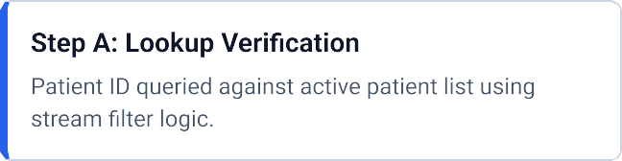
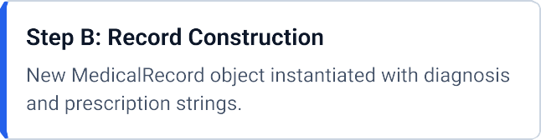

The underlying Java codebase consolidates key components cleanly into structured classes. Key class responsibility declarations are detailed below.

Core Class Declarations

Application Management Layer
The `HospitalApp` class acts as an in-memory database controller, maintaining references to all collections:
    - List<Patient> patients: Central registry of all active patients.
    - List<Doctor> doctors: Registry of medical staff pre-populated at startup.
    - List<Appointment> appointments: Historical schedule ledger.
    - List<Invoice> invoices: Financial billing tracking list.

Performance and scalability analysis of the core in-memory collections used in the application.

Asymptotic Time & Space Complexity

Operation | Target Entity | Time Complexity | Space Complexity
Patient Registration | Patient | O(1 ) | O(1 )
ID Search Routine | Patient / Doctor | O(N) | O(1 )
Appointment Creation | Appointment | O(N) search + O(1 ) insert | O(1 )
Medical History Display | MedicalRecord | O(K) records | O(1 )

Collection Design Evaluation
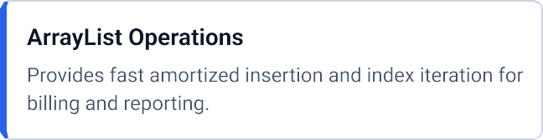
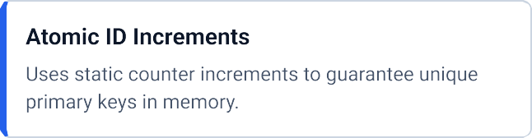

System reliability is ensured through systematic validation across menu inputs and data entry points.

Test Case Execution Summary

Test Case | Input Parameter | Expected Behavior | Status
TC-01 | Register Patient ("John", 30, "M") | Creates record with ID PAT- 1 001 . | PASS
TC-02 | Book with invalid Patient ID | Displays error string; cancels invoice creation. | PASS
TC-03 | Add Record to missing Patient | Catches null entity lookup gracefully. | PASS
TC-04 | Menu Navigation Overﬂow | Handles out-of-range option choices smoothly. | PASS

Defensive Programming Patterns
    - Null Guard Logic: Methods verify non-null entity references before creating dependent instances.
    - Scanner Buffer Management: Explicit `nextLine()` calls prevent input skip bugs during numerical parsing.
    - State Encapsulation: Private collection handles prevent direct external modiﬁcation of system state.

A comparative evaluation highlights the eﬃciency gain of this digital system over paper-based records and generic spreadsheet tools.

System Feature Comparison Matrix

Evaluation Feature | Paper Register | Spreadsheet | HMS Java System
Record Lookup Speed | Slow (Minutes) | Moderate | Instant (< 1 ms)
Automatic Invoicing | No | Manual Formulas | Fully Automated
Data Encapsulation | None | Low | High (OOP Enforced)
Medical History Integrity | Risk of Loss | Overwriting Risk | Immutable Append Only
Setup Overhead | None | Low | Minimal (Portable Java)

Strategic Beneﬁts
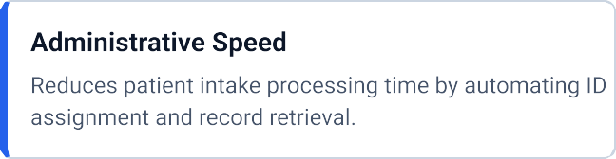
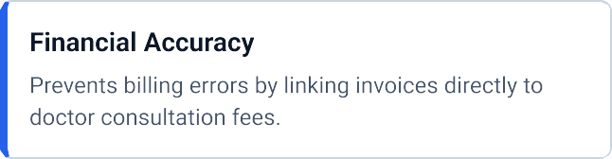

The system architecture provides a foundation for future extensions. The planned upgrade path spans three main phases:
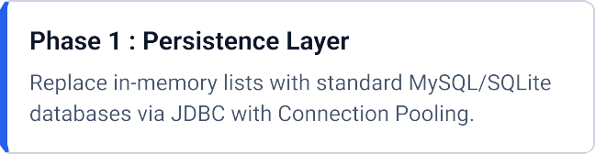
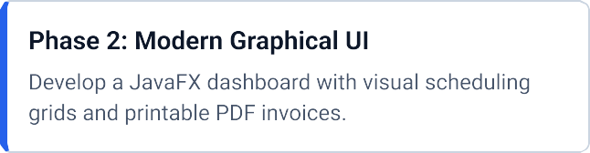
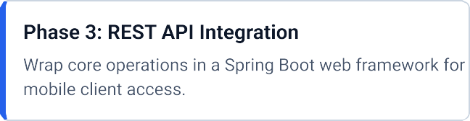
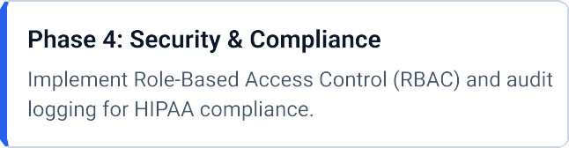

1 0. CONCLUSION

The Hospital Management System demonstrates how core Object-Oriented Software Engineering principles can streamline medical administrative workﬂows. By enforcing encapsulation, automated identiﬁer creation, and modular entity relationships, the system provides a clean, extensible foundation ready for production-grade database integration and modern user interfaces.

